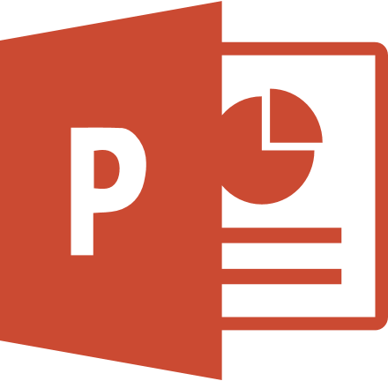

This document has been created in previous
Microsoft Office version.

In order to display this presentation correctly, it must be opened in Microsoft Office PowerPoint application, and then:

  - Enable Editing button has to be clicked,
  - Enable Content button has to be clicked.

Those two buttons will make the Microsoft Office PowerPoint convert this document to the newest version.

